Skills sets  - Project Scope, Planning, & Prioritizing | Resource Requirements & Management | Scheduling, Organizing, & Time Management | Project Initiation Document(PID) , Systems Integration Testing ( SIT), User Acceptance Testing (UAT) , disaster management, Quality Assurance (QA) /QC | Project Requirements Gathering & Analysis | Oral & Written Communication Skills | Milestone Development & Deliverables Tracking | Team Leadership & Cross-Functional Team Collaboration | Project Budget Planning & Administration | Best Practices in Project Management Methodology | Analytical Thinking, Problem Solving, & Attention to Detail | Microsoft: Project, Word, Excel, PowerPoint, Access, Visio | Agile Scrum Methodologies & Waterfall | Service Now , Jira , Confluence, AutoCAD , DCIM  - Delivery/ implementation and Migration of Legacy Data Center to SDN/Cisco/Arista SW , ACI Infrastructure using devices management by network orchestration Cisco NSO, APIC Cluster, Spines Nexus 9504, UTP leafs Nexus 9300, Fiber Leafs Nexus 9300, Border Leafs Nexus 9300, OOB SW Catalyst 9200, Cisco wireless-lan-controllers CDN Expansion, SDWAN/VPN network platform, Cloud Modernization, MPLS infrastructure in enterprise networking  - Data center decommissioning/Relocation and exit and end user migration on new setup.  - Deployment/Migration of Legacy Network, security, fixed-line, broadband and Data Centers to next generation technology in Access, Core, enterprise Network in ISP/Telecom.  - Telecommunications Projects (Wireline experience optical fiber & UTP systems) Implementation and Testing & commissioning in Data Center / Data Room/Communication room  - Work Knowledge of Ethernet, TCP/UDP, ICMP IPv4 / IPv6 , IGMP, IPFM, IP, MPLS, GPON, OSPF, BGP, HSRP, VLANS, MPLS,  - Cisco CUCM, Avaya Contact Centre (IP Telephony) deployment in Access and Enterprise Network.  - Network Assurance, End User Hardware/Software upgrades, Service Desk Support, IT Infrastructure, Information Security, and Physical Security  - DWDM Network & E2E GPON Implementation and Testing & commissioning for IP Broadband solutions in Mobily Network.  - Distributed Data Center Enhancement Project (DDCE) / Mission-Critical Facility: Implementation. Integration and Testing & commissioning of Covering 20 DC of different locations in CE, US & UK, APAC, EMEA region, Data Center enhancement of Back-up Generator Uninterruptible Power Supply (UPS), Distributed Transformer, Heating and Ventilation Air Conditioning (HVAC), Fire Fighting and Alarm System ,Close Circuit Television System (CCTV), Lenel Access Control System ,Environmental Monitoring System, Electrical Wiring ,Grounding and Earthling System, Communication and OFC & Copper Network System, Data Center Cabinets/Racks, Architectural and Civil Works  - Establish new Data Center Network to cater for future expansion, Expand the existing Campus Network of Air Bases.  - E2E Service Delivery of IAM & PAM from multi-factor-authentication Cisco Duo, PKI, SailPoint, beyond Trust, CyberArk, Delinea.  - Work Knowledge of compliance standards knowledge like ISO27001, PCI, GDPR  - SSE/vProxy, Cisco Firewall, Cisco IPS/IDS, Cisco DDoS, akamai & cloudflare WAF, F5 LB/ASM, Juniper firewalls, fortigate firewalls, DNS Management and Network Registration  - Data Center Migration from on-prem to Mobily private & public cloud AWS/ Azure / Akamai/ Cloudflare cloud  - AWS/Azure DevOps/ continuous integration,  delivery and deployment (CI/CD)  - Work Knowledge & hand on OSWAP Top 10 Attack, Full proxy Architecture, BIG-IP, TMOS, ASM, Hybrid Security Architecture, Deploy Security Policies, License Provisioning, Resource Provisioning, Web Security Analytics, Custom Rules, IP/Geo Firewall, L7 Attacks, DOS /DDOS Protection, Bot Manager, DNS, SSL/TLS, CDN-Caching  - Data center/OS/Servers/ Storage / Database network /security appliance upgrades to next generation technology.  - Application Deployment/Migration in Main Data Center & DR and Cloud in Mobily  - API Performance solutions from Akamai  - VM network infrastructure delivery in data center & Cloud.  - Implementation and Testing & commissioning of the ICT LAN system components (LAN & Structured UTP & Fiber Cabling), & Physical Security (CCTV system, Access Control) intrusion Detection System, IP Telephony & Intercom System and Weather System in ICT Package in Metro & DC Project  - Cisco CUCM, Avaya Contact Centre deployment in Access and Enterprise Network.  - Airport ICT Infrastructure  - Security Systems, Passive and Active Network Solutions, Audio-Visual, IoT and Wired, Wireless & Mobile Networks  - ITSM tools (ServiceNow, Remedy, Solarwinds , vulnerability management by Skybox /Tenable/qualys Patch Management/ Release Management/Service & Incident management  - NetApp, NetQlik , Networker, Iserver, NAMI, share point, Remedy, DCIM, DCFIE, splunk SIEM | Project RAID logs I C-level stakeholders Communication  Rewards  - Certificate of Excellence from Indian Army 16 INF  - Certificate of Appreciation from Indian Army Signal Regiment  - Certificate of Excellence from RSAF for DC Project  - Certificate of Excellence from Airports Authority of India for Networking (LAN, WLAN) and or Cyber Security  - Certificate of Appreciation from Emircom for Mobily Projects in 2020 & 21 | 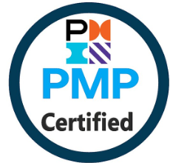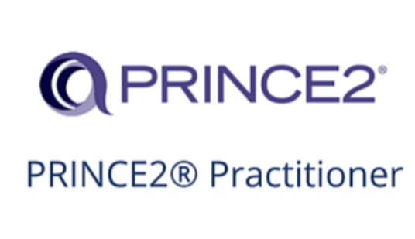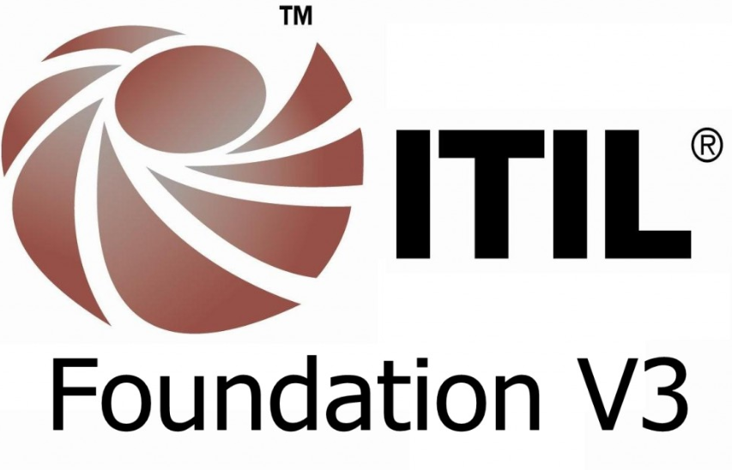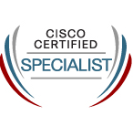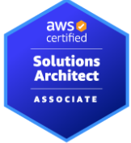  IMRAN KHAN +447770388857 | imran.datacenter@gmail.com Flat 53, Lakeside, 82 Eaton Drive, Kingston Upon Thames, Surrey, London, UK KT2 7RA  - Senior Global Technical Project Manager - CACI, Deutsche Bank (Data Center Transformation/GCP/Azure/AWS Cloud Migration/ Remediation of User/System/Secure connectivity, Vulnerability & bug and NDSM Management, Compliance Management and Cyber & Network Security and IT/Telecom/LAN/WAN/Fiber Infrastructure/ Mission-Critical Facility/Data Center Builds, Consolidations, Decommissions  - Highly skilled professional with more than 15+ years of experience managing large-scale traditional Waterfall and Scrum projects. Well-versed in leveraging cross-functional E2E Deployment/Migration and implementation of global Data Centre Transformation (CE, US & UK, APAC, EMEA region) , Cisco ACI ,SD-WAN/SDN-LAN transformation, Remediation of User/System/Secure connectivity , Vulnerability Management, Compliance Management and and Cyber Security, WAF, Data Center Migration, Core & Enterprise Network Security, Telecom, IT Infrastructure, Remediation of User/System/Secure connectivity, Agile, and QA teams to complete project deliverables on time and within budget. Demonstrated success applying project management best practices, technical expertise, and business acumen to consistently achieve targeted results in (Tier 1/2) public telecoms providers.  - Vast Knowledge of deployment/Migration of Legacy Network, security, IP broadband and Data Centers to next generation technology in Core & enterprise Network and (Tier 1/2) public telecoms providers & Banks, Airports, Airbase, Hotels, Indian Army, Metro Projects  International & India Assignments:  - Data Centers & Disaster recovery (DR) Migration from Legacy to SD-WAN /SDN Cisco ACI Project  - Data Center Mission Critical Migration on-prem to Mcloud public/Private O365/Prod/Dev/UAT & GCP Private Prod/Dev/UAT application.  - Managing the Service delivery/implementation and Migration of front-end applications & Rest Api to Cloudflare, Akamai, AWS, Azure cloud. And migrate relational database SQL(RDS), aurora database & No SQL database, dynamo database to same cloud as per business requirement.  - Managing the Service delivery/implementation and Migration from Existing IAM to Cloud base IAM solution from Cisco Duo and beyondtrust.  - Facebook, Google, Cloudflare & Akamai WAF CDN Expansion Projects  - Data center decommissioning and exit & relocate new location and end user migration on new setup & also 24X7 Managed service support for standard chartered bank Dubai  - IP Telephony Project  - NetApp/ ONTAP data management software (Element tool) Tech Refresh Service delivery/implementation and Migration project In DC & DR.  - Data Encryption and Key management Project  - Cisco IPS/IDS Tech Refresh Project  - IGW ASAv Firewall VPN Gateway Services Expansion Project  - Technical Building & Economy offload & Jed 1 Exchange Project  - VPN Gateway Firewall Replacement Project  - DDoS Protection Project  - FireEye - Tech Refresh Project  - E2E Deployment/Migration and implementation of COTS Applications.  Dynamics Deployment/Migration and implementation of ePortal LP Application, ePortal Web Application, IVR Application, USSD Application, APIGee Application, Mobile App (B2C, B2B and Tafeely) Application, Tafeely Web Application in Mobily using SQL database  .  - Services delivery of SAP HANA Infrastructure implementation and Deployment/Migration in Main Data Center & DR and Cloud in Mobily  - Service delivery/implementation and Migration of VMs for ccTLD are hosted FAYHA , Malga DDOS on VMware Exsi in which I used Red Hat Enterprise Linux as per business requirement & worked on Veeam Backup & Replication (back up, restore and replicate data on virtual machines (VMs)  - Data center decommissioning  - Network expansion in Core & enterprise network Project  - Designing, Implementation and Testing & commissioning of the ICT systems  - Service Delivery of Tier-III Data Center Migration (DCM) & DCFIE projects  - Speed Test Project  - Implementation. Integration and Testing & commissioning of the Central ICT LAN NMS Servers (This Central NMS Server that will monitor all network nodes & utilities sector e.g switches, IP phones, workstation and Servers) with SCADA Server in ICT Package3(Line4,5,6) Riyadh Metro Project  - Rollout legacy VAS & the Service delivery of New Value-added Services (VAS) Modernization  - HSN 24X7 Support project Riyadh and Migration ATM to IP/MPLS  - Dubai Airport IT department for their various issues regarding connectivity, security frame changes and addition of new hardware  - Managing multiple turnkey projects for Tulip - PAN India (ASWAN, MP-SWAN, Jubilant Foods Limited (Dominos), CCTNS Rajasthan [Crime and Criminal Tracking Network & Systems]  - Implementation of Network for Airport Authority of India  Experiences  04/2024 to Till Date  CACI, Deutsche Bank  Senior Global Technical Project Manager - Cloud/Datacenter transformation/Migration /Network and Cyber Security  01/2019 – 12/2023  Emircom Company, Mobily, Etihad Etisalat Co  Technical Project Manager- Cloud/Datacenter Migration /IT Infrastructure /WAN transformation/ Network/Security and Telecom Infrastructure  07/2016 - 12/2018  Taj Systems Company Ltd.  Engineering Manager- implementation and Migration  05/2014 - 06/2016  System Networks Company Ltd  Project Manager -Data Center & IT/Telecom Infrastructure  10/2012 - 05/2014  Tulip Telecom  Operation Manager-Security/Network  11/2009 - 09/2012  Native Solution Company Ltd  Project Manager- Data Center & Security/Network and NOC  06/2008 - 09/2009  Alpha Data LLC  Sr. Network Engineer  02/2005 - 05/2008  Spanco Limited  Assistant Manager-Past Sales, International (Muscat, Oman) & National Projects  Education and Certifications  Bachelor of Science, India  Master Of Business Administration (IT), India  Project Management Certificate (PMP)  PRINCE2 Foundation Certificate  PRINCE2 Practitioner  ITILv3 Foundation Certificate  Cisco Data Center Design certificate (CCNP), NCSS  AWS Certified Solutions Architect

Project Details

CACI, Deutsche Bank

Client: Deutsche Bank
Role: Senior Technical Project Manager- Cloud/Datacenter Migration & Network and Cyber Security

Projects & Responsibility:

A# Managing the Service delivery/implementation and Migration related to Azure Virtual Desktop (Only from an on prem connectivity perspective)
1# Data Center & Cloud migration, Cyber Security Standard implementation in WAF, Application Layer 3 , 4 , 7 Security
2# WAF implementation and resolve all technical issues individually or in support with CDN/WAF customer care or professional services.
3# Direct and ensure the successful outcome of projects - coordinate with vendor technical project team and CDN/WAF solution engineer

4# To coordinating various teams in the planning, execution, implementation and their successful conclusion for WAF related activities in the project.
5# To work closely with stakeholders by setting expectations, managing scope and risk, communicating status to senior management and ensure project meets designed business outcomes and objectives.
6#Own the technical components of an integration project including configuration changes, debugging, documentation, testing, and go live support
7# Understanding of Software quality management, quality control management and version control management
8# Delivery of HLD, LLD, NIP, NRFU as-built documentation & implementation and support in Datacenters, cloud , Security/Network , enterprise &Core network
9# Lead programs which consist of multiple projects ; projects within the program may share dependencies, and delivery of the overall program will enable realization of benefits across the program, and achieve customer value
•Provide vision, strategy, governance and business objective alignment
•Responsible for program metric tracking, and managing financials and profitability
•Provide leadership and hold the customer and program team accountable to deliver programs on-time, within budget, with high quality while achieving customer satisfaction
•Perform overall program-level planning, resource management, stakeholder engagement, communications planning and oversight of interdependent projects ensuring smooth transition to Operations
•Act as a mentor and first point of escalation to Project Managers
•Identify opportunities for additional business, provide input to presales evaluation, requirements gathering, and renewals
•Identify risk, issues and develop risk response strategy at the program level
•Lead the execution of contract Change Management process at the program level
•Manage partner/subcontractor delivery and commercials
Leader and first point of escalation to program teams
Identify cross-program risk, issues and risk response strategy; ensure Change Management execution to ensure delivery and contract alignment for program duration

Emircom Company, Mobily, Etihad Etisalat Co
(Contract)

Client: Mobily, Etihad Etisalat Co
Role: Project Manager- Network/Security/DC and Telecom Infrastructure
Product: Cisco, Technologies: Cisco ACI, Azure Cloud Tools: Remedy, Jira, Microsoft: Project, share point
Project Description

A# Managing the Service delivery/implementation and Migration from Existing ITD, GSM and DND segments from Malga 1 & 2 DC to Cisco ACI multi-tenant fabric implemented as standalone single pod fabric in spine-leaf topology for Malga I & II Datacenter in Mobily (Etihad Etisalat Co.)

B# And Migration of front-end applications & Rest Api and Database from on-prem to Public Azure cloud using IaaS/PaaS/SaaS & Azure DevOps/CI/CD as per Customer business requirement. And Managing the Service delivery/implementation and Migration of COTs applications.
C# Managing the Service delivery/implementation and Migration from Existing IAM to Cloud base IAM solution from Cisco Duo and beyondtrust

Emircom Company, Mobily, Etihad Etisalat Co (Contract)

Client: Mobily, Etihad Etisalat Co
Role: Project Manager- Network/Security/DC and Telecom Infrastructure
Product: HP, Telenity & Multivendor Technologies: VAS , Tools: Remedy, Jira, Microsoft: Project , confluence , share point
Project Description
Managing rollout legacy VAS & the Service delivery of New Value-added Services (VAS) Modernization - Finance applications, AntiSpam, MCN, SMSC, USSD, RSC, Voice Mail, Collect Call (Pay for me), NFV VAS Generic VNF Manage, RBT, Digital installation & implementation of HPE 3PAR 8000 Storage.

Emircom Company, Mobily, Etihad Etisalat Co (Contract)

Client: Mobily, Etihad Etisalat Co
Role: Project Manager- Cyber & Network Security and DC
Product: Cisco Technologies: IPS & IDS Tools: Remedy, Jira, Microsoft: Project , confluence , share point
Project Description
Managing rollout legacy FMC and IPS & IDS with Latest version and Mobily - VPN Gateway Firewall Replacement in Mobily security Network. And Managed by Cisco NSO /OSS Stack
Emircom Company, Mobily, Etihad Etisalat Co (Contract)

Client: Mobily, Etihad Etisalat Co
Role: Project Manager- Network/Security/DC and Telecom Infrastructure

Product: Akamai/Facebook/Medianova/Cloudflare Technologies: CDN expansion
Tools: Remedy, Jira, Microsoft: Project , confluence , share point
Project Description
Managing the Service Delivery/implementation of Akamai/Facebook/Medianova/Cloudflare/Speed Test/Google / CDN expansion in Mobily (Etihad Etisalat Co.) Datacenters. And Managed by Cisco NSO /OSS Stack

Emircom Company, Mobily, Etihad Etisalat Co (Contract)

Client: Mobily, Etihad Etisalat Co
Role: Project Manager- Cyber & Network Security and DC
Product: Nexus , Cisco Technologies: PKI , Cisco Duo , RSA ,Tools: Remedy, Jira, Microsoft: Project , confluence , share point
Project Description
Managing the Service Delivery of Mobily Public Key Infrastructure Deployment with vendor-Nexus (establishing PKI for securing LTE) & Hardware Security Module (UTIMACO) and factor-authentication Cisco Duo (IAM) , RSA in Mobily (Etihad Etisalat Co.) And Managed by Cisco NSO /OSS Stack

Emircom Company, Mobily, Etihad Etisalat Co (Contract)

Client: Mobily, Etihad Etisalat Co
Role: Project Manager- Cyber & Network Security and DC
Product: Cisco Technologies: DDoS , Cisco ASA ,Tools: Remedy, Jira, Microsoft: Project , confluence , share point
Project Description
Managing the Service Delivery of Mobily DDoS Protection and Mobily Site to Site IPSEC VPN to Tawakkalna using Cisco ASAv in Mobily IGW.

Taj Systems Company Ltd. (Contract)

Client: Riyadh Metro
Role: ICT & IT Project Manager-Product: Cisco Technologies: Cisco ACI , SDN , Cisco CUCM ,Tools: Remedy, Jira, Microsoft: Project , share point
Project Description
Designing, Implementation and Testing & commissioning of the ICT LAN system components (LAN & Structured Cabling), CCTV system, Access Control & Introduction Detection System, IP Telephony & Intercom, Cyber Security/Network System and Weather System in ICT Package3(Line4,5,6) Riyadh Metro Project.

Native Solution Company Ltd

Client: RSAF
Role: NOC Service Delivery Manager Product: Cisco Technologies: IP/MPLS, Tools: Remedy, Jira, Microsoft: Project, share point
Project Description
HSN 24X7 Support project Riyadh and Migration ATM to IP/MPLS in all Airbase Saudi Arabia:
Working as a Project Manager/NOC Manager and supporting Data/Transmission Problem in 24X7 RSAF NOC. And Managed by Cisco NSO /OSS Stack

Tulip Telecom

Client: CCTNS project, Rajasthan Police
Role: Project Manager- Data Center & Security/Network Product: HP, Cisco Technologies: IP/MPLS, Tools: Remedy, Microsoft: Project, share point
Project Description
The CCTNS project aims at creating a comprehensive and integrated system for enhancing the efficiency and effectiveness of policing at (1090) the Police Station level through adoption of principles of e-Governance, and creation of a nationwide networked infrastructure for evolution of IT-enabled state-of-the-art tracking system around “investigation of crime and detection of criminals” in the real time

Spanco Ltd., India

Client: Airport Authority of IndiaRole: Assistant Manager-Past Sales Product: Cisco Technologies: IP/MPLS
Tools: Remedy, Microsoft: Project, share point
Project Description
Implementation of Network for Airport Authority of India that was distributed to all over India and covering various cities such as Indore, Jaipur, Srinagar, Ahmedabad, Allahabad, Varanasi etc and HQ being at Delhi.

